number of overtakes between bicycles and mopends

2020112921 刘欣豪

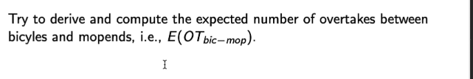

对于bicycle与mopeds，mopeds的速度为vi，bicycle的速度为vj

